**DEBUGGING &TRACEABILITY**

|  |  |
| --- | --- |
| DATE | 16 November 2022 |
| TEAM ID | PNT20022TMID46949 |
| PROJECT NAME | Classification of arrhythmia by using deep learning with 2-D ECG spectral image representation |
| MAXIMUM MARK | 2 Marks |

**DEBUGGING :**

Debugging, in computer programming and engineering, is amultistep process that involves identifying a problem, isolating the source of the problem, and then either correcting the problem or determining a way to workaround it. The final step of debugging is to test the correction or workaround and make sure it works.

1.Recognize that a bug exists.

2. Isolate the source of the bug.

3. Identify the cause of the bug.

4. Determine a fix for the bug.

5. Apply the fix and test it.

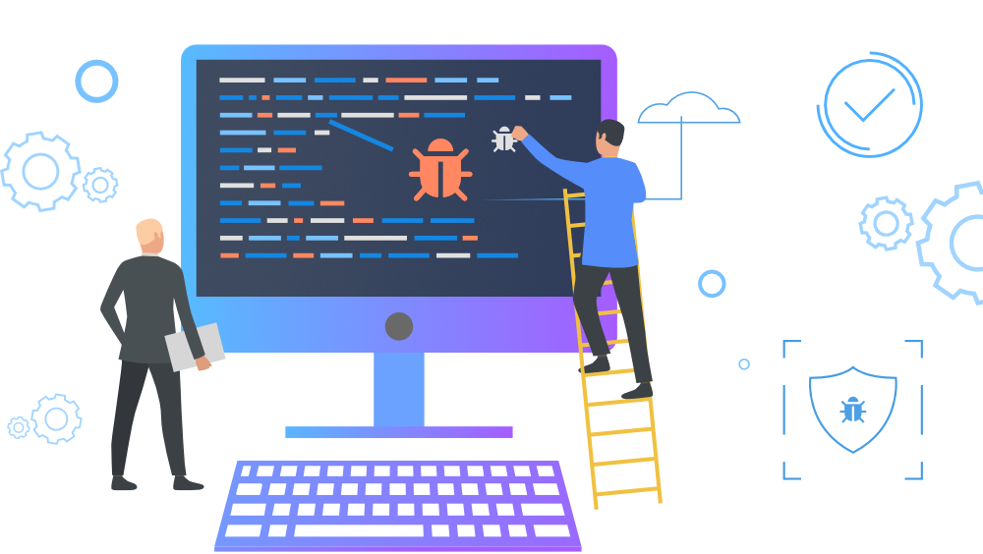

**TRACEABILITY:** Traceability is as it the ability to track something moves throughaprocess. In product development, it refers to the ability to track and trace requirements to artifacts, test runs, and anything else in the product lifecycle.

